**BUILD A PYTHON CODE , ASSUME YOU GET A TEMPERATURE AND HUMIDITY VALUES GENERATED WITH RANDOM FUNCTION TO A VARIABLE AND WRITE A CONDITION TO CONTINUOUSLY DETECT ALARM IN CASE OF HIGH TEMPERATURE.**

**Program**

**import random**

**import winsound**

**temperature= random.randrange(0,100)**

**print(temperature)**

**if(temperature>60):**

**print("HIGH TEMPERATURE")**

**#print('\a')**

**winsound.Beep(4460, 10000)**

**else:**

**print("NORMAL TEMPERATURE")**

**difference=random.randint(3,8)**

**dewpoint=temperature-difference**

**print("dewpoint=",end=" ")**

**print(dewpoint)**

**#Relative Humidity**

**rh=100*(2.718281828*(17.625*dewpoint/(243.04+dewpoint)))/(2.718281828*(17.625*temperature/(243.04+temperature)))**

**print("Relative Humidity=",end=" ")**

**print(rh)**

**OUTPUT**

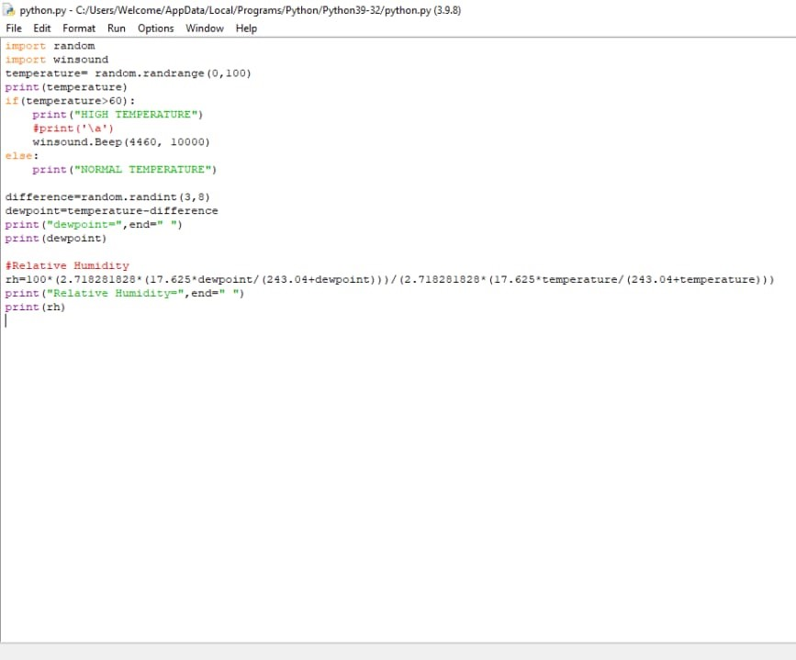

**Vedio link:**

**https://drive.google.com/file/d/1zeKJFT0QxJqeyL1WVDVsLgOnR_9lpZI-/view?usp=sharing**